

**UNIVERSIDAD TECNOLÓGICA DE**

**SAN LUIS RIO COLORADO**

**MOCK UPS**

**MTR. AURELIO FLORES**

**ALUMNO: VICTOR MANUEL GALVAN COVARRUBIAS**

**ING. EN DESARROLLO Y GESTIÓN DE SOFTWARE**

San Luis Rio Colorado, Sonora Febrero, 2022

**DEFINITION**

A mockup is a montage of high-quality photos that is used in design and advertising to present designs to the client.

Examples:

* Logos.
* Websites.
* Packaging or views of a product.

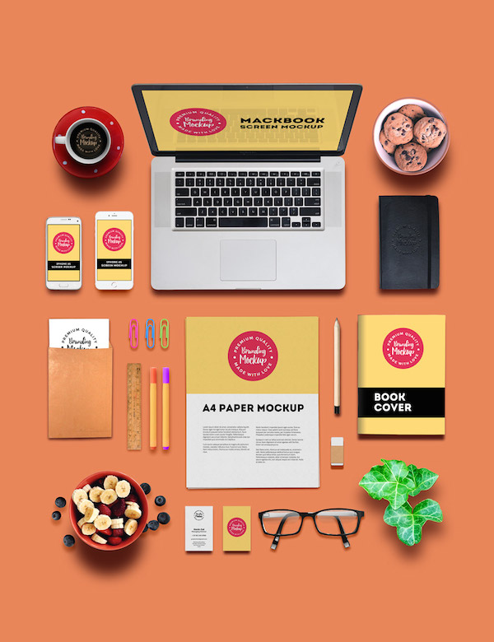

Mockups take into account design options such as colors, typography, image size, iconography, and the overall appearance of the product.

**ADVANTAGES**

1. Money saver: they make us save a lot, because it is modifiable as many times as we want.
2. Visualization of ideas: through these we capture our ideas.
3. Visualization of final works: clients will be able to see through the mockups the result they are looking for.
4. Professionalism: using mockups adds value to our work to strengthen the qualities of the brand.
5. Sales improvement: the use of mockups makes the proposals made to clients more impressive, resulting in accelerated sales.

**DISADVANTAGES**

1. Expected results: the client wants to start working from the moment the mockup is proposed, since this is only an idea of the final product.
2. Discussions: Mockups cause problems when they are presented to customers in an uncontrolled way. Since customers focus on superficial things and there may be a feeling of discomfort from it.
3. Client dependency: Mockups always depend on the client's decisions and what they decide to do for the creation of the final product.
4. Required experience: mockups are often made wrongly, since those in charge of developing them do not have basic software knowledge.

**WHEN TO USE THEM**

* When we present our work we are dealing with physical items.
* When time is not available.
* When not many resources are available.
* When you want to present different logos to the client.
* When you want to present different visual styles of the product.